**Telecom App Hybrid Architecture (Updated - 1)**

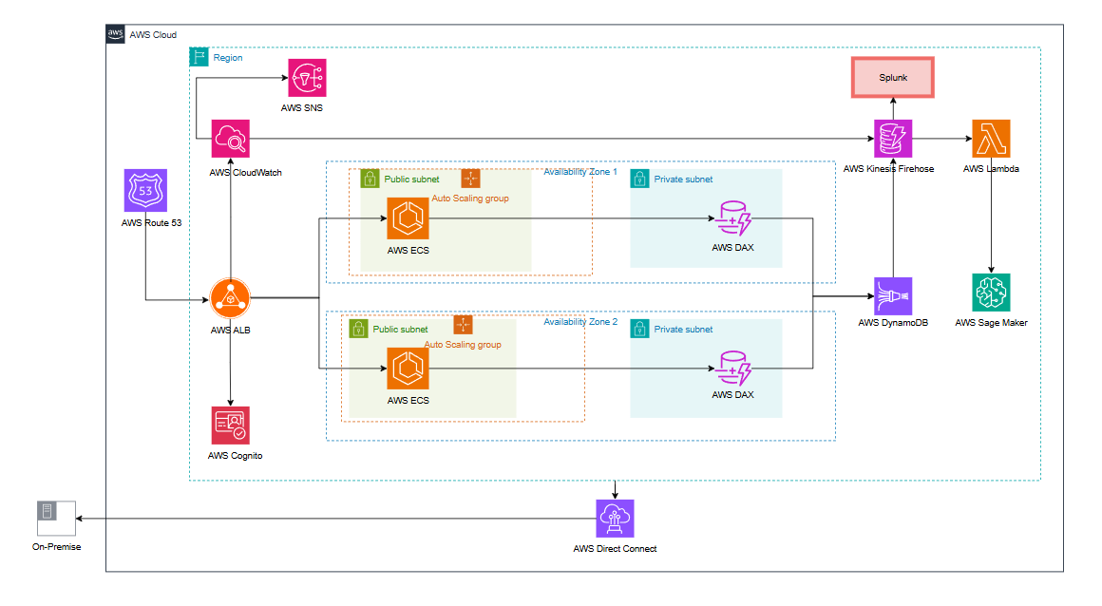

**Services Used and Their Roles**

1. **AWS Route 53**: Manages DNS and routes incoming traffic to the appropriate AWS resources.
2. **AWS Cognito**: Provides user authentication and authorization.
3. **AWS ALB (Application Load Balancer)**: Distributes incoming traffic across multiple ECS tasks running in the Auto Scaling groups.
4. **AWS ECS (Elastic Container Service)**: Hosts containerized applications and ensures scaling with Auto Scaling groups.
5. **Auto Scaling Group**: Automatically adjusts the number of ECS tasks based on demand, ensuring optimal resource utilization.
6. **AWS DynamoDB**: A NoSQL database used for storing and retrieving application data with low latency.
7. **AWS DAX (DynamoDB Accelerator)**: Provides caching for DynamoDB to improve read performance.
8. **AWS CloudWatch**: Monitors the application, resources, and services, sending alerts via SNS when thresholds are breached.
9. **AWS SNS (Simple Notification Service)**: Sends notifications to relevant parties or systems based on CloudWatch alarms.
10. **AWS Direct Connect**: Provides a dedicated network connection between on-premises infrastructure and AWS for low latency and secure data transfer.
11. **AWS Kinesis Firehose**: Processes and delivers streaming data to destinations like Splunk for real-time analytics.
12. **Splunk**: Used for log analysis and real-time monitoring of the application.
13. **AWS Lambda**: Executes serverless functions for data processing or triggering workflows.
14. **AWS SageMaker**: Supports machine learning model training, deployment, and inference.

**Workflow**

1. Traffic from users is routed through **AWS Route 53** to the **Application Load Balancer (ALB)**.
2. **ALB** distributes incoming traffic across multiple ECS tasks running in different Availability Zones (AZs).
3. User authentication and authorization are handled via **AWS Cognito**.
4. The application running on ECS interacts with **DynamoDB** to retrieve or store data, with **DAX** providing caching to improve performance.
5. **Kinesis Firehose** collects streaming data for processing and forwards it to **Splunk** for logging and monitoring or to downstream applications.
6. Data or workflows requiring additional computation are processed using **Lambda** functions.
7. Machine learning tasks are handled by **AWS SageMaker**, which interacts with the database and other services as needed.
8. Monitoring and alerting are managed by **CloudWatch** and **SNS**, while **Direct Connect** facilitates secure data transfer between on-premises and the cloud.

**High Availability**

1. **Multi-AZ Deployment**: ECS tasks are distributed across two Availability Zones to ensure redundancy.
2. **Auto Scaling Groups**: Automatically scale ECS tasks based on demand, ensuring consistent application performance.
3. **DynamoDB and DAX**: Fully managed, distributed services provide built-in high availability and fault tolerance.
4. **ALB**: Ensures load balancing across healthy ECS tasks in different AZs.
5. **SNS and CloudWatch**: Proactively monitor and alert in case of service degradation or failure.
6. **Direct Connect**: Reduces network disruptions by providing a dedicated connection between on-premises infrastructure and AWS.

**Cost Optimization Suggestions**

1. **Use Spot Instances for ECS**: Consider running ECS tasks on Spot Instances for significant cost savings if workloads are fault-tolerant.
2. **Right-Sizing**: Continuously monitor and adjust instance types and sizes to match application requirements.
3. **Reserved Instances or Savings Plans**: Purchase Reserved Instances or Savings Plans for predictable workloads to reduce EC2 costs.
4. **Optimize DynamoDB Usage**: Use on-demand capacity for unpredictable workloads and provisioned capacity for predictable patterns.
5. **Enable Auto Scaling**: Ensure Auto Scaling groups for ECS and DynamoDB are fine-tuned to scale in during low-traffic periods.
6. **Consolidate Data Processing**: Use fewer, more efficient Lambda functions to minimize execution time and costs.
7. **Optimize Data Transfer**: Use AWS Direct Connect efficiently by minimizing cross-region data transfers.
8. **Use CloudWatch Metrics Sparingly**: Avoid excessive custom metrics to reduce monitoring costs.
9. **Archival for Logs**: Use lower-cost storage solutions like S3 for long-term log retention instead of Splunk.